**CREATE A DATABASE IN CLOUDANT DB**

|  |  |
| --- | --- |
| DATE | 26 OCTOBER 2022 |
| TEAM ID | PNT2022TMID26620 |
| PROJECT NAME | Personal Assistance for Seniors Who Are Self-Reliant |

**AIM :**

TO CREATE A DATABASE IN CLOUDANT DB TO STORE LOCATION DATA.

**STEPS TO BE INVOLVED :**

**STEP 1 :** LOG IN INTO IBM CLOUD AND SEARCH CLOUDANT THEN OPEN IT AND CREATE A LITE ACCOUNT

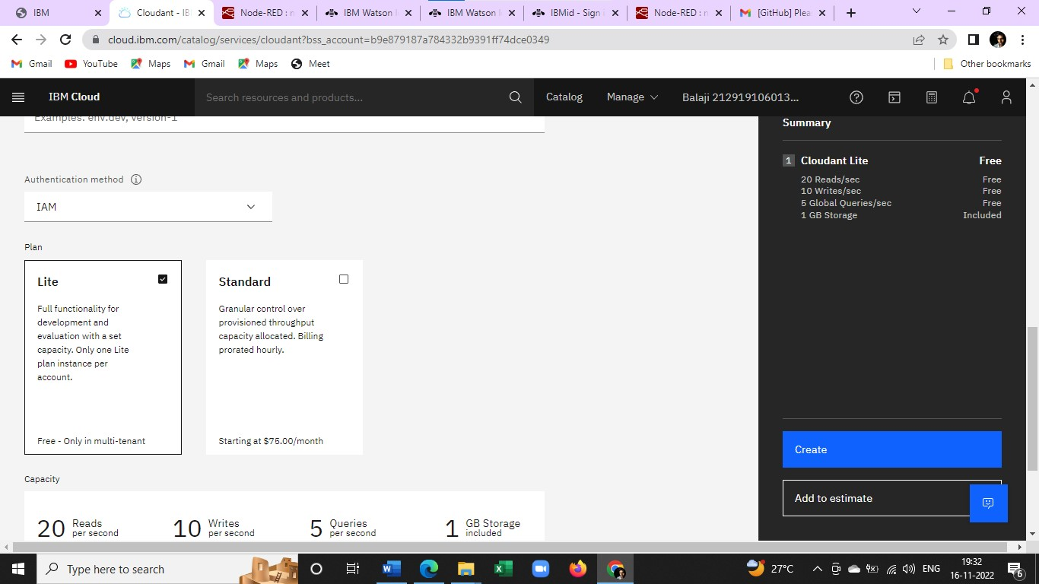

**STEP 2 :** CLOUDANT ACCOUNT WAS SUCCESSFULLY CREATED

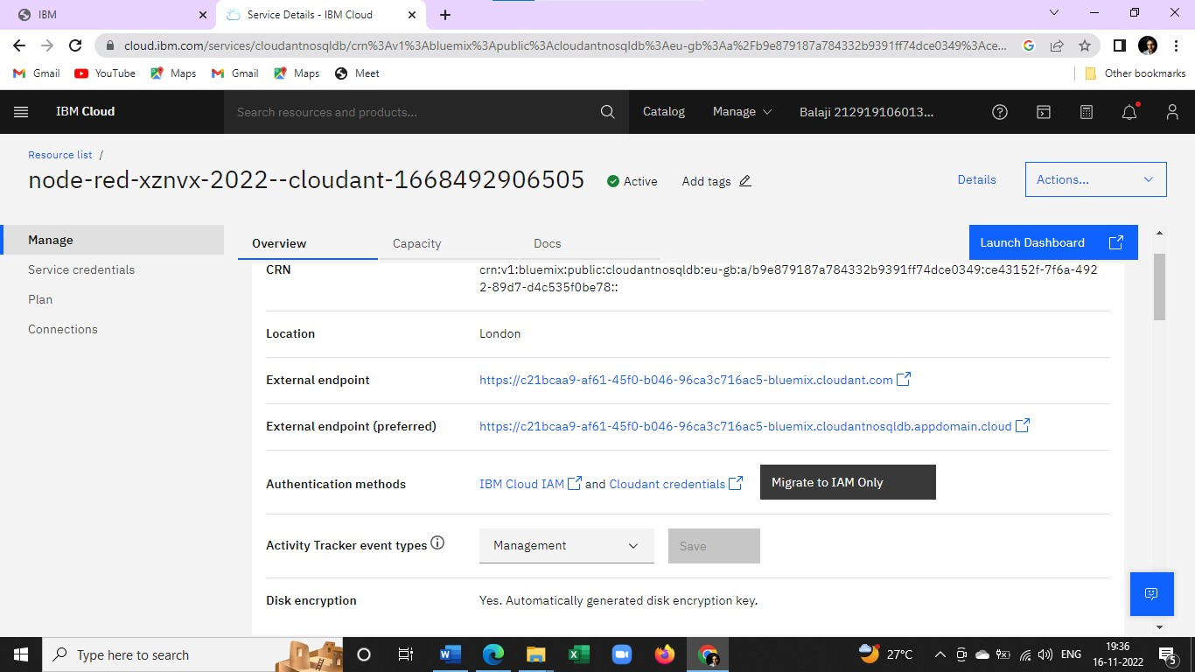

**STEP 3 :** CLICK ON LAUNCH DASHBOARD AND CREATE A DATABASE

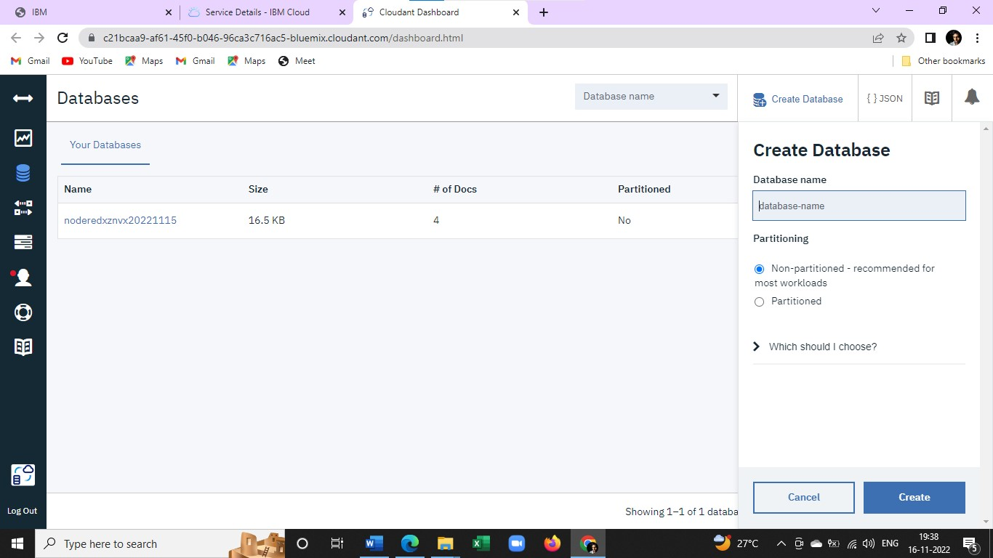

**STEP 4 :** DATABASE WAS SUCCESSFULLY CREATED.

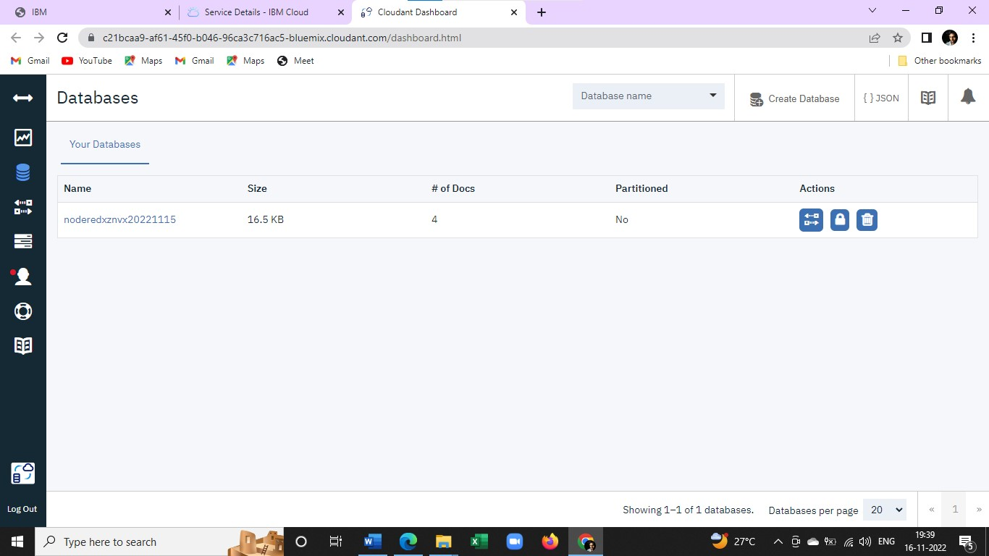

**RESULT :** A DATABASE TO STORE THE LOCATION WAS CREATED SUCCESSFULLY ON CLOUDANT DB.